LAB ASSIGNMENT - 3

NAME :- Aindrail Santra ROLL NO :- 2029044

Q1.

<!DOCTYPE *html*>

<html *lang*="en">

<head>

    <meta *charset*="UTF-8">

    <meta *http-equiv*="X-UA-Compatible" *content*="IE=edge">

    <meta *name*="viewport" *content*="width=device-width, initial-scale=1.0">

    <style>

        h1{

            background-color: darkgray;

        }

        .div1{

            font-family: 'Gill Sans', 'Gill Sans MT', Calibri, 'Trebuchet MS', sans-serif;

            font-size: x-large;

            border-style: dotted ;

            padding: 5px;

            margin: 10px;

        }

        .div2{

            font-family: 'Trebuchet MS', 'Lucida Sans Unicode', 'Lucida Grande', 'Lucida Sans', Arial, sans-serif;

            font-size: xx-large;

            border-style: solid ;

            padding: 15px;

            margin: 50px;

        }

    </style>

    <title>Internal Inline External Style </title>

    <link *rel*="stylesheet" *href*="Q1_style.css">

</head>

<body>

    <center>

        <h3 *style*="background-color: rgb(9, 67, 138); color: azure; width: 25% ; padding: 5px; font-size: xx-large;  "

         >

OCEANS

        </h3>

        <p *style*="background-color: rgba(98, 126, 209, 0.353); padding: 5px; font-family: 'Lucida Sans', 'Lucida Sans Regular', 'Lucida Grande', 'Lucida Sans Unicode', Geneva, Verdana, sans-serif; "  >

            The ocean (also the sea or the world ocean) is the body of salt water that covers approximately 70.8% of the surface of Earth and contains 97% of Earth's water.[1] Another definition is "any of the large bodies of water into which the great ocean is divided".[2] Separate names are used to identify five different areas of the ocean: Pacific (the largest), Atlantic, Indian, Southern (Antarctic), and Arctic (the smallest).[3][4] Seawater covers approximately 361,000,000 km2 (139,000,000 sq mi) of the planet. The ocean is the principal component of Earth's hydrosphere, and therefore integral to life on Earth. Acting as a huge heat reservoir, the ocean influences climate and weather patterns, the carbon cycle, and the water cycle.

The ocean covers ~70% of the Earth, sometimes called the "blue planet"

Oceanographers divide the ocean into different vertical and horizontal zones based on physical and biological conditions. The pelagic zone consists of the water column from surface to ocean floor throughout the open ocean. The water column is further categorized in other zones depending on depth and on how much light is present. The photic zone includes water from the surface to a depth of 1% of the surface light (about 200 m in the open ocean), where photosynthesis can occur. This makes the photic zone the most biodiverse. Photosynthesis by plants and microscopic algae (free floating phytoplankton) creates organic matter using light, water, carbon dioxide, and nutrients. Ocean photosynthesis creates 50% of the oxygen in earth's atmosphere.[5] This upper sunlit zone is the origin of the food supply which sustains most of the ocean ecosystem. Light only penetrates to a depth of a few hundred meters; the remaining ocean below is cold and dark. The continental shelf where the ocean approaches dry land is more shallow, with a depth of a few hundred meters or less. Human activity has a greater impact on the continental shelf.

Ocean temperatures depend on the amount of solar radiation reaching the ocean surface. In the tropics, surface temperatures can rise to over 30 °C (86 °F). Near the poles where sea ice forms, the temperature in equilibrium is about −2 °C (28 °F). Deep seawater temperature is between −2 °C (28 °F) and 5 °C (41 °F) in all parts of the ocean.[6] Water continuously circulates in the oceans creating ocean currents. These directed movements of seawater are generated by forces acting upon the water, including temperature differences, atmospheric circulation (wind), the Coriolis effect and differences in salinity.[7] Tidal currents originate from tides, while surface currents are caused by wind and waves. Major ocean currents include the Gulf Stream, Kuroshio current, Agulhas current and Antarctic Circumpolar Current. Collectively, currents move enormous amounts of water and heat around the globe. This circulation significantly impacts global climate and the uptake and redistribution of pollutants such as carbon dioxide by moving these contaminants from the surface into the deep ocean.

Ocean water contains large quantities of dissolved gases, including oxygen, carbon dioxide and nitrogen. This gas exchange takes place at the ocean surface and solubility depends on the temperature and salinity of the water.[8] The increasing concentration of carbon dioxide in the atmosphere due to fossil fuel combustion leads to higher concentrations in ocean water, resulting in ocean acidification.[9] The ocean provides society with important environmental services, including climate regulation. It also offers a means of trade and transport and access to food and other resources. Known to be the habitat of over 230,000 species, it may contain far more – perhaps over two million species.[10] However, the ocean is subject to numerous environmental threats, including marine pollution, overfishing, ocean acidification and other effects of climate change. The continental shelf and coastal waters that are most influenced by human activity are especially vulnerable.

        </p>

        <h3 *style*="background-color: rgb(69, 233, 178); color: rgb(245, 236, 240); width: 25% ; padding: 5px; font-size: xx-large;  "

        >

            SEAS

        </h3

        >

        <p

*style*="background-color: rgba(103, 230, 200, 0.353); padding: 5px; font-family: 'Lucida Sans', 'Lucida Sans Regular', 'Lucida Grande', 'Lucida Sans Unicode', Geneva, Verdana, sans-serif; "

        >

            The sea, connected as the world ocean or simply the ocean, is the body of salty water that covers approximately 71 percent of the Earth's surface. The word sea is also used to denote second-order sections of the sea, such as the Mediterranean Sea, as well as certain large, entirely landlocked, saltwater lakes, such as the Caspian Sea.

The sea moderates Earth's climate and has important roles in the water cycle, carbon cycle, and nitrogen cycle. Humans harnessing and studying the sea have been recorded since ancient times, and evidenced well into prehistory, while its modern scientific study is called oceanography. The most abundant solid dissolved in seawater is sodium chloride. The water also contains salts of magnesium, calcium, potassium, and mercury, amongst many other elements, some in minute concentrations. Salinity varies widely, being lower near the surface and the mouths of large rivers and higher in the depths of the ocean; however, the relative proportions of dissolved salts vary little across the oceans. Winds blowing over the surface of the sea produce waves, which break when they enter the shallow water. Winds also create surface currents through friction, setting up slow but stable circulations of water throughout the oceans. The directions of the circulation are governed by factors, including the shapes of the continents and Earth's rotation (the Coriolis effect). Deep-sea currents, known as the global conveyor belt, carry cold water from near the poles to every ocean. Tides, the generally twice-daily rise and fall of sea levels, are caused by Earth's rotation and the gravitational effects of the orbiting Moon and, to a lesser extent, of the Sun. Tides may have a very high range in bays or estuaries. Submarine earthquakes arising from tectonic plate movements under the oceans can lead to destructive tsunamis, as can volcanoes, huge landslides, or the impact of large meteorites.

A wide variety of organisms, including bacteria, protists, algae, plants, fungi, and animals, live in the sea, which offers a wide range of marine habitats and ecosystems, ranging vertically from the sunlit surface and shoreline to the great depths and pressures of the cold, dark abyssal zone, and in latitude from the cold waters under polar ice caps to the colourful diversity of coral reefs in tropical regions. Many of the major groups of organisms evolved in the sea and life may have started there.

The sea provides substantial supplies of food for humans, mainly fish, but also shellfish, mammals and seaweed, whether caught by fishermen or farmed underwater. Other human uses of the sea include trade, travel, mineral extraction, power generation, warfare, and leisure activities such as swimming, sailing, and scuba diving. Many of these activities create marine pollution. The sea has therefore been for humans an integral element throughout history and culture.

        </p>

<h3

*style*="background-color: aqua; color: azure; width: 25% ; padding: 5px; font-size: xx-large;  "

>

    RIVERS

</h3>

<p

*style*="background-color: rgba(155, 245, 245, 0.646); padding: 5px; font-family: 'Lucida Sans', 'Lucida Sans Regular', 'Lucida Grande', 'Lucida Sans Unicode', Geneva, Verdana, sans-serif; "

>

    A river is a natural flowing watercourse, usually freshwater, flowing towards an ocean, sea, lake or another river. In some cases, a river flows into the ground and becomes dry at the end of its course without reaching another body of water. Small rivers can be referred to using names such as stream, creek, brook, rivulet, and rill. There are no official definitions for the generic term river as applied to geographic features,[1] although in some countries or communities a stream is defined by its size. Many names for small rivers are specific to geographic location; examples are "run" in some parts of the United States, "burn" in Scotland and northeast England, and "beck" in northern England. Sometimes a river is defined as being larger than a creek,[2] but not always: the language is vague.[1]

Melting toe of Athabasca Glacier, Jasper National Park, Alberta, Canada

Rivers are part of the hydrological cycle. Water generally collects in a river from precipitation through a drainage basin from surface runoff and other sources such as groundwater recharge, springs, and the release of stored water in natural ice and snowpacks (e.g., from glaciers).

Rivers and streams are often considered major features within a landscape; however, they actually only cover around 0.1% of the land on Earth. They are made more obvious and significant to humans since many human cities and civilizations are built around the freshwater supplied by rivers and streams.[3] Most of the major cities of the world are situated on the banks of rivers, as they are, or were, used as a source of water, for obtaining food, for transport, as borders, as a defensive measure, as a source of hydropower to drive machinery, for bathing, and as a means of disposing of waste.

Potamology is the scientific study of rivers, while limnology is the study of inland waters in general.

</p>

    </center>

   <h1>

       Aindrail Santra

   </h1>

   <h1>

       CSCE

   </h1>

   <h1 *style*="background-color: burlywood;" >

       2029044

   </h1>

   <h1 *style*="background-color: burlywood;" >

       KIIT

   </h1>

   <center>

       <p *style*="font-size: x-large; "

        >

               HOVER BACKGROUND

       </p>

   </center>

   <div *class*="div1" >

           DIV_1

   </div>

   <hr>

   <div *class*="div2" >

         DIV_2

   </div>

</body>

</html>

External CSS :-

body{

    background-color: rgb(221, 235, 231);

}

p{

    background-color: blueviolet;

    padding: 5px;

}

p:hover{

    background-color: chartreuse;

}

OUTPUT

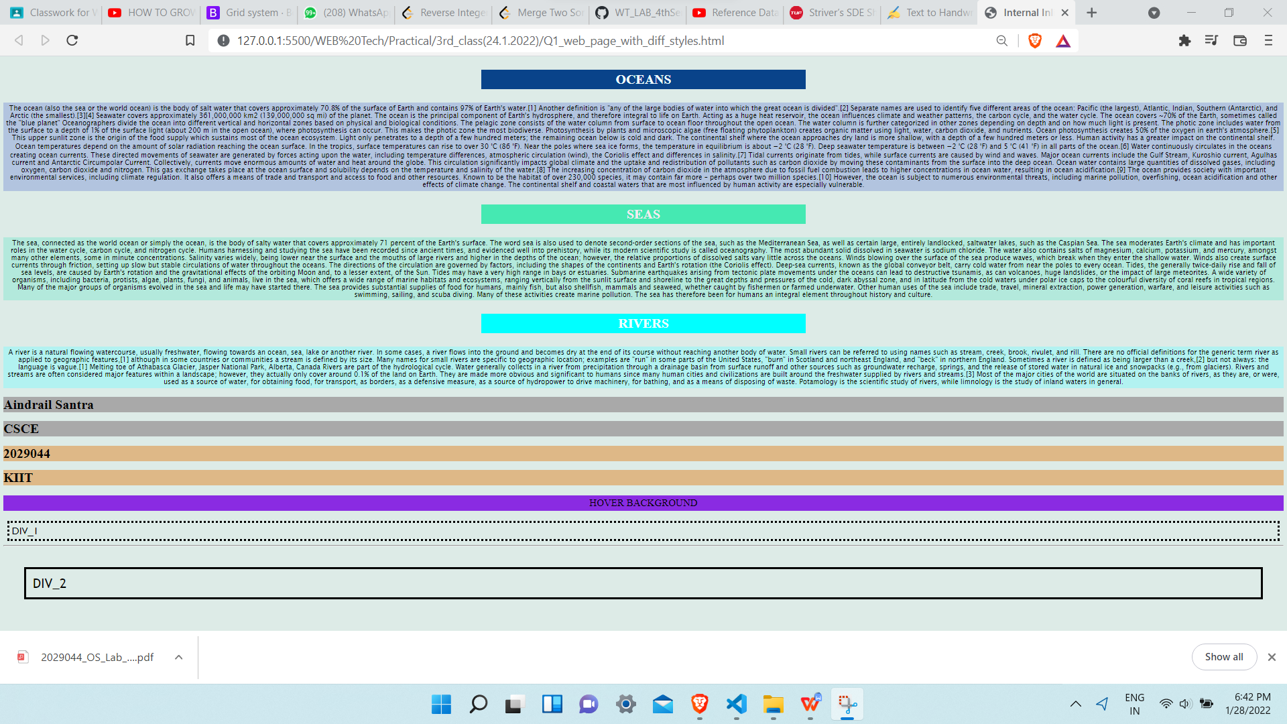

Q2.

<!DOCTYPE *html*>

<html *lang*="en">

<head>

    <meta *charset*="UTF-8">

    <meta *http-equiv*="X-UA-Compatible" *content*="IE=edge">

    <meta *name*="viewport" *content*="width=device-width, initial-scale=1.0">

    <title>Form</title>

    <link *rel*="stylesheet" *href*="Q3_style_1.css">

</head>

<body>

    <div *class*="cointainer" >

        <form *action*="">

            <p>Username :* <input *type*="text" *name*="Name" *placeholder*="ex:-Aindrail Santra" *required*></p>

            <p>

                Password :* <input *type*="password" *name*="Password" *id*="Password" *minlength*="7" *maxlength*="13" *required*>

            </p>

            <hr>

            <center>

                <button *style*=" padding-left: 15px; padding-right: 15px; background-color: rgb(72, 230, 72);">

                    <a *href*="Q2_sencond_page.html" *style*="font-size: x-large; " *onclick*='alert("Registration Successfull")'>

                            SUBMIT

                    </a>

                </button>

            </center>

        </form>

    </div>

</body>

</html>

OUTPUT

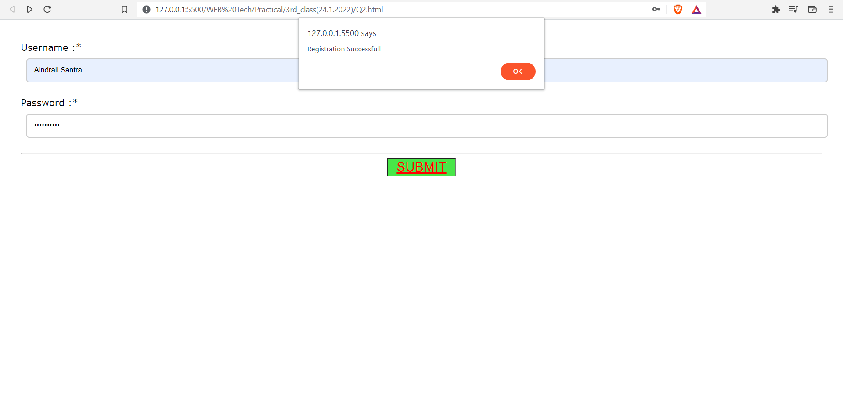

Q3.

<!DOCTYPE *html*>

  <html *lang*="en">

  <head>

      <meta *charset*="UTF-8">

      <meta *http-equiv*="X-UA-Compatible" *content*="IE=edge">

      <meta *name*="viewport" *content*="width=device-width, initial-scale=1.0">

      <title>Registration Form</title>

      <link *rel*="stylesheet" *href*="Q3_style_1.css">

  </head>

  <body>

      <div *class*="container">

        <form *action*="">

            <h1 *style*="text-align: center;" *class*="main_heading"> Facebook Registration </h1>

            <h3 *style*="font-size: smaller; color: red;">(* represent required field)</h3>

            <h2>Registration Information</h2>

  <p>Firstname :* <input *type*="text" *name*="Name" *placeholder*="ex:-Ram Singh" *required*></p>

  <p>Lastname :* <input *type*="text" *name*="Name" *placeholder*="ex:-Singh" *required*></p>

  <p>

    Password :* <input *type*="password" *name*="Password" *id*="Password" *minlength*="7" *maxlength*="13" *required*>

</p>

<p>

    Re-enter Password :* <input *type*="password" *name*="Password" *id*="Password" *minlength*="7" *maxlength*="13" *required*>

</p>

  <fieldset>

      <legend>Gender :*</legend>

      <p>

          <input *type*="radio" *name*="Gender" *id*=""*required*> Male <br>

          <input *type*="radio" *name*="Gender" *id*=""*required*> Female <br>

           <input *type*="radio" *name*="Gender" *id*=""*required*> Others <br>

      </p>

  </fieldset>

  <fieldset>

    <legend>Hobbies :*</legend>

    <p>

        <input *type*="radio" *name*="Hobbies" *id*=""*required*> Sports field <br>

        <input *type*="radio" *name*="Hobbies" *id*=""*required*> Indoor field <br>

         <input *type*="radio" *name*="Hobbies" *id*=""*required*> Art & Crafts <br>

         <input *type*="radio" *name*="Hobbies" *id*=""*required*> Others <br>

    </p>

</fieldset>

<p>

    Birth Date :* <input *type*="date" *name* ="exp_date" *id* = "exp_date" *required*>

</p>

  <p>

      Address :* <textarea *name*="" *id*="Address" *cols*="100" *rows*="7" *required*></textarea>

  </p>

  <p>

      Email : <input *type* ="email" *name*="Email" *id*="email">

  </p>

  <p>

   URL : <input *type*="url" *id*="homepage" *name*="homepage">

  </p>

  <hr>

  <div *class* ="submitbutton">

    <input  *type*="submit" *value*="Submit">

    <br><br>

    <input *type*="reset"  *value*="Reset">

  </div>

        </form>

      </div>

  </body>

  </html>

CSS file

*{

    box-sizing: border-box;

 }

 body{

     font-family: Verdana, Geneva, Tahoma, sans-serif;

     margin: 15px 30px;

     font-size: 17px;

     padding: 8px;

 }

 .container{

     background-color: #dcf5f1;

     padding: 5px 20px 15px 20px ;

     border: 1px solid lightgrey;

     border-radius: 4px ;

 }

 input[type="text"],

 input[type="email"],

 input[type="number"],

 input[type="password"],

 input[type="date"],

 select,

 textarea{

      width:100%;

     padding: 12px;

     border: 2px solid #ccc;

     border-radius: 5px;

     margin: 10px;

 }

 fieldset{

     background-color :#fff;

     border: 2px solid #ccc;

 }

 .main_heading{

     text-align: center;

 }

 input[type="submit"]

 {

    text-align: center;

     background-color: rgb(10, 160, 15);

     color: #fff;

     padding: 12px 20px;

     border: none;

     border-radius: 4px;

     cursor: pointer;

     width: 150px;

 }

 input[type="submit"]:hover{

     background-color: rgb(207, 216, 40);

 }

 input[type="reset"]

 {

    text-align: center;

     background-color: rgb(220, 39, 39);

     color: #fff;

     padding: 12px 20px;

     border: none;

     border-radius: 4px;

     cursor: pointer;

     width: 150px;

 }

 input[type="reset"]:hover{

     background-color: rgb(216, 81, 40);

 }

 .submitbutton{

    text-align: center;

 }

OUTPUT

